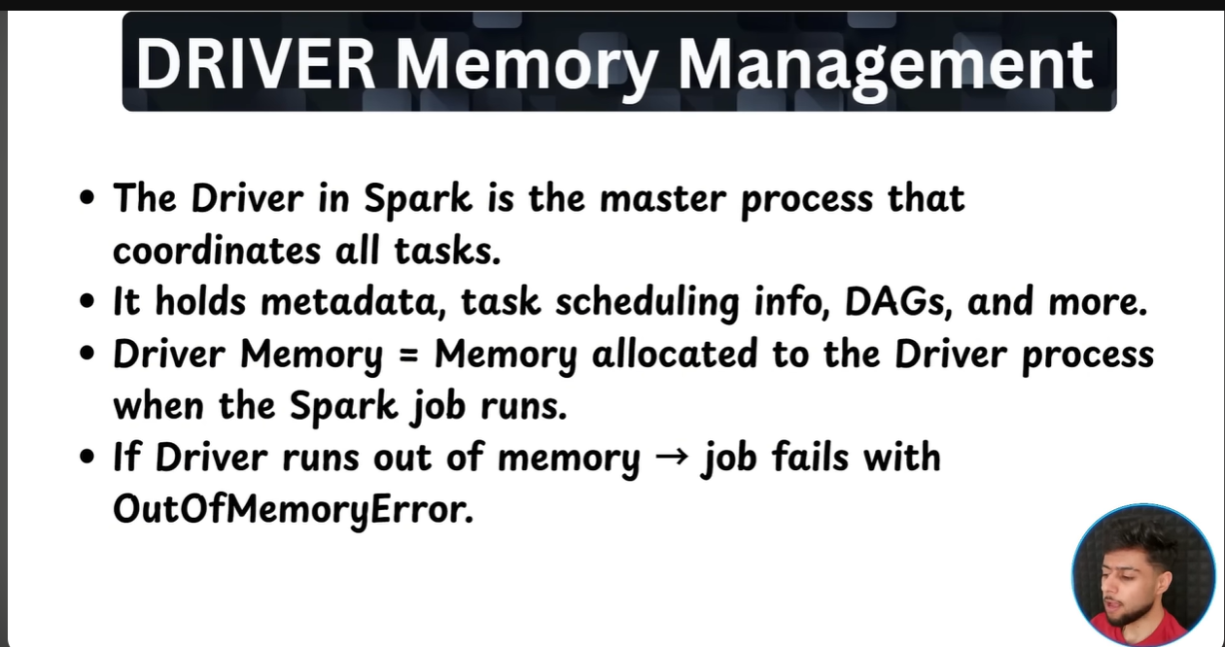

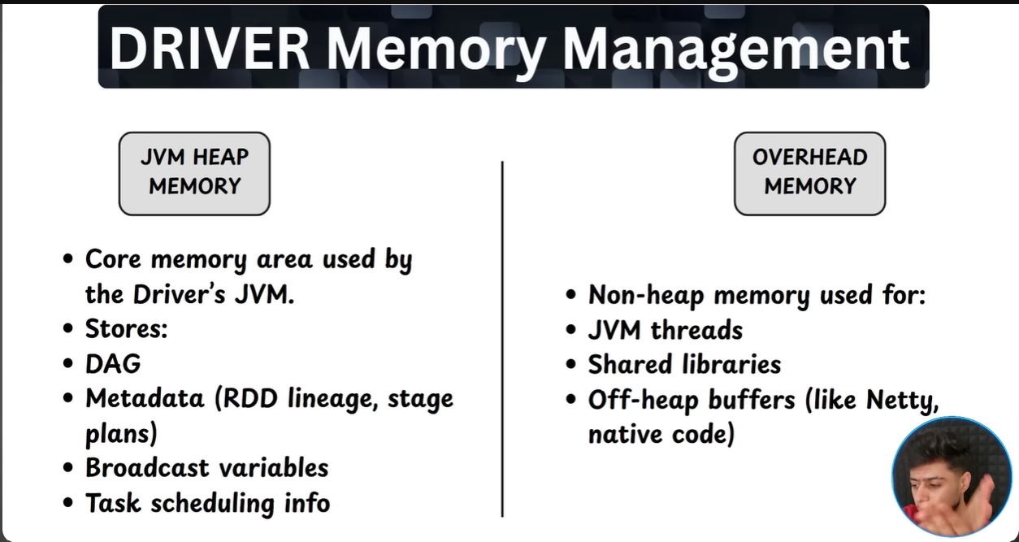
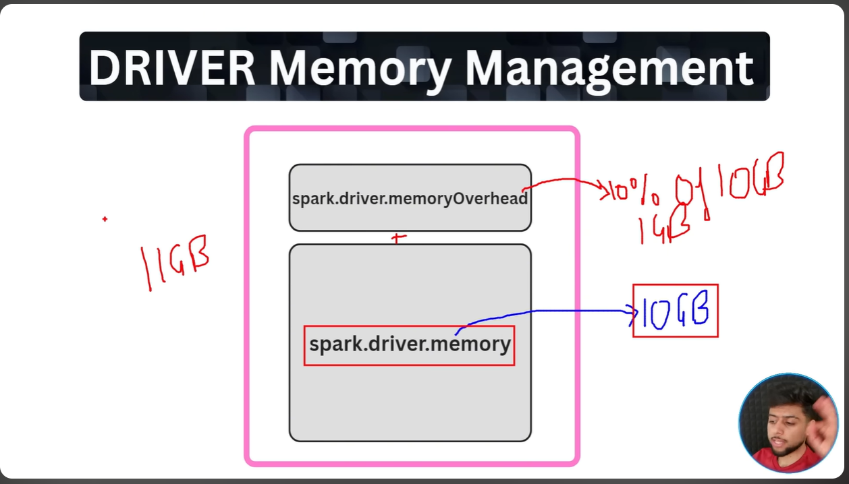

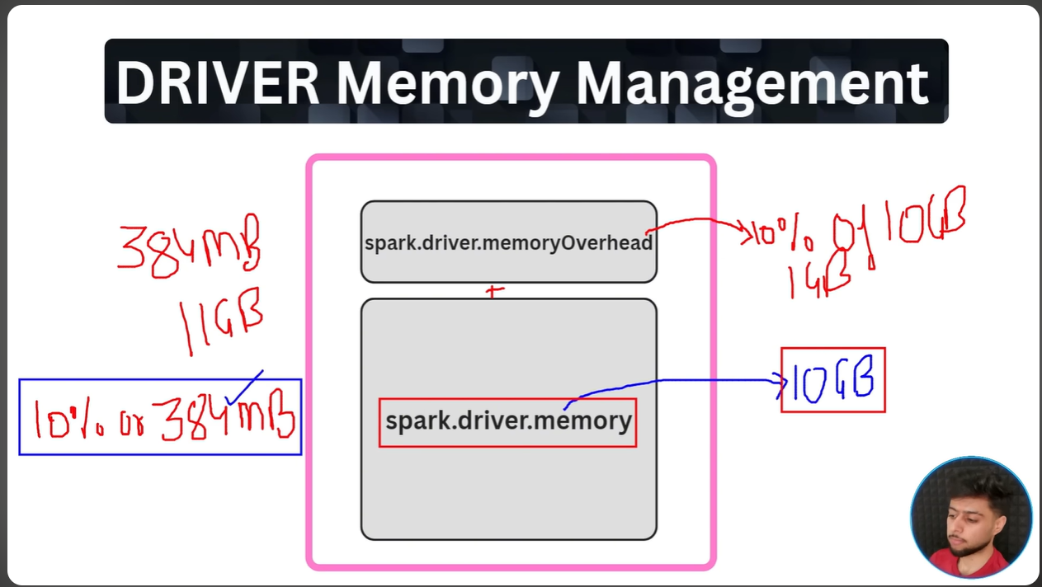
Note: Driver uses JVM’s heap memory to broadcast variables, so if broadcast variables data size is larger than heap memory itself it will throw the Out of memory exception.

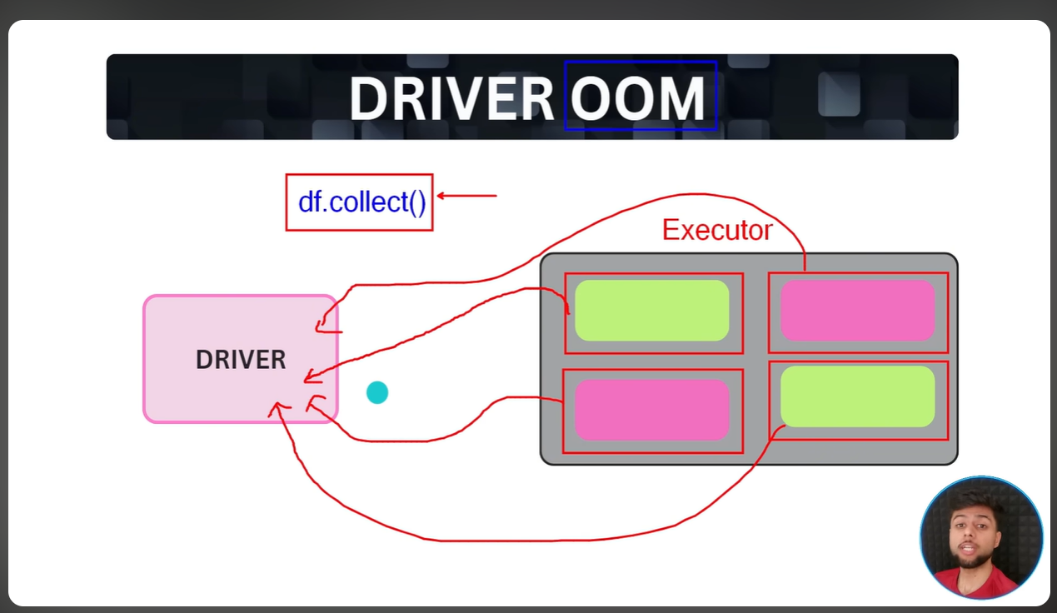
The action methods like df.collect() we should use wisely because it combines all the partitions which causes the risk for Memory OO exception in case if size of partition exceeds size of driver memory.

